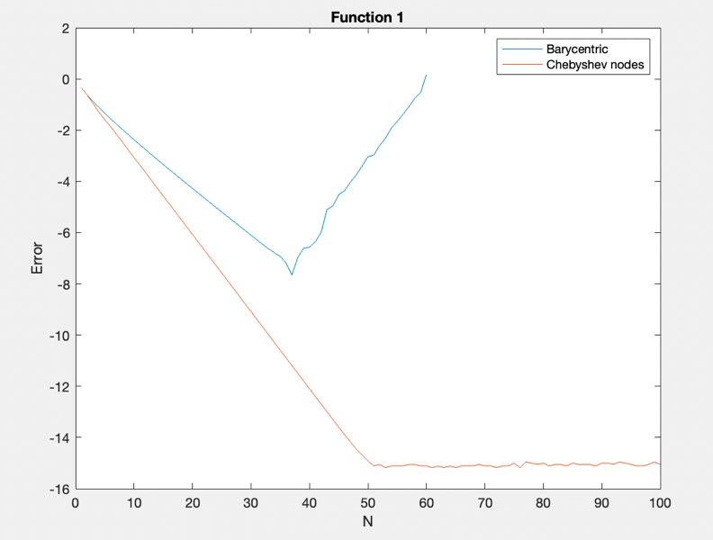We were asked to conduct analysis on the robustness and accuracy of interpolation based on the nature of the nodes.

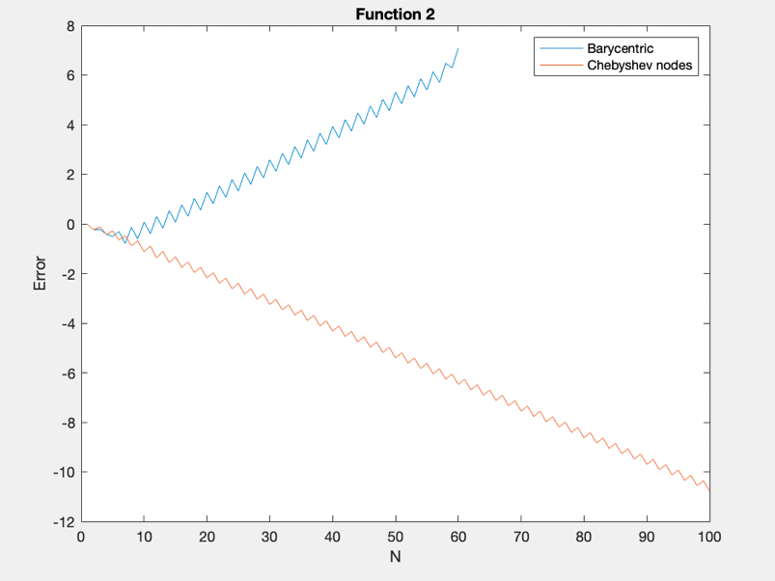For the function 1/(5-4x) the errors for equally spaced using barycentric interpolation nodes reduces linearly for n = 40 and then reaches its most accurate point at n = 40. Beyond that it increases linearly until n = 60. After which n becomes too large which causes the error to become approximately 10^2. When using Chebyshev the error reduces and accuracy improves linearly and finally plateaus at roughly n =50. The approximations are significantly better than barycentric technique.

For the function 1/(1+16x^2) the interpolation error follows a zig-zag pattern but increases linearly up to n = 60 and follows similar behaviour as function 1 and causes the error to become approximately 10^2. While using Chebyshev nodes the error follows a similar zig zag pattern but reduces linearly, improving accuracy.

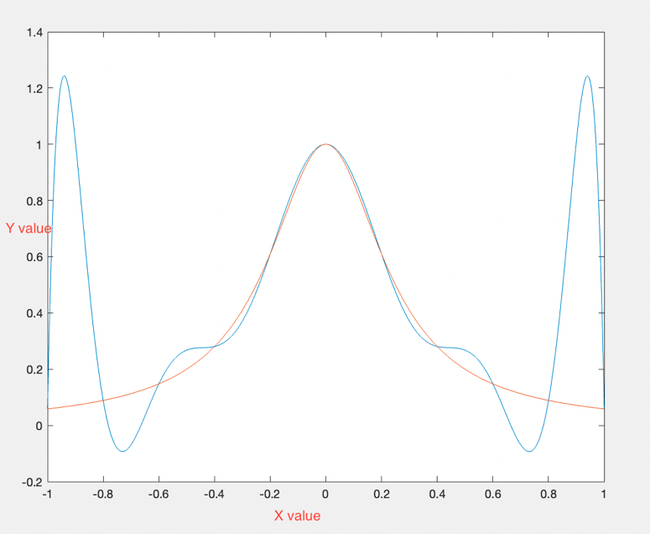These inaccuracies in equally spaced nodes is called the Runge’s phenomenon which causes an oscillating error at the edges. This can be seen in Figure 3 which closely approximates for function 2 roughly the middle 80% and scatters at the endpoints. Since the degree of this function is higher Runge’s phenomenon is evident.

In both the functions for Chebyshev nodes the error is the highest at lower values of n. The errors are lesser than that of the barycentric method, making it more robust and accurate to the nature of the nodes. Runge’s phenomenon cannot be observed.

Chebyshev nodes are more accurate because its points they are closer to the equally spaced nodes which gives better approximating polynomials.

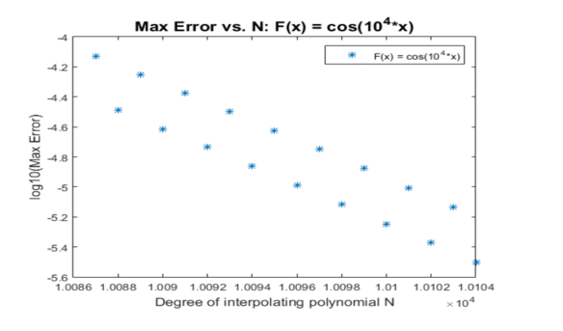For f3(*x*) = cos(10^4\**x*)*,* the smallest value of n such that error *≤* 10^-5 was found to be approximately 10100.